Electricity - 08
CLASS 10 - SCIENCE

 | Section A
1 | A bird sitting on an 11,000 V wire is quite safe but a man touching 220 V wire may die. Why do ? | [2]
2 | Why are fairy decorative lights always connected in parallel? | [2]
3 | What is meant by saying that the potential difference between two points is 1 V? | [2]
4 | Define:  - Potential  - Potential difference. | [2]
5 | There are three 2 V cells connected in series. How many joules of energy does 1 C gain on passing through all the three cells? | [2]
6 | How much energy is given to each coulomb of charge passing through a 6V battery? | [2]
7 | A wire of resistance 2$Ω$ has been connected to a source of 50 V as its two ends. What is the current flowing through the wire ? | [2]
8 | If a student wants to connect four cells of 1.5 V each to form a battery of voltage 6 V, then how would he draw the symbol of the battery? | [2]
9 | What do you mean by an electric circuit? Carefully study the circuit diagram given below and make the necessary corrections. 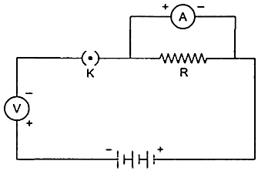 | [2]
10 | Shyam designed a burglar alarm circuit in which the resistors are connected in series. The circuit breaks and the current did not flow through the circuit. What is the alternate method he should opt to prevent the circuit break when the resistors are connected in series? | [2]
11 | Draw a schematic diagram of a circuit consisting of 3V battery, 5 ‎Ω, 3 ‎Ωand 1 Ω resistor, an ammeter and a plug key, all connected in series. | [2]
12 | Distinguish between an open and a closed circuit. | [2]
13 | Draw the symbols of the following components that are used in the circuit diagram:  - Wires crossing without joining  - Variable resistance or rheostat  - A battery or a combination of cells | [2]
14 | Name the instrument used to measure potential difference across two points in a circuit and state how it should be connected in the circuit. | [2]
15 | What precautions should be taken while performing this experiment? | [2]
16 | What would you suggest to a student if while performing an experiment he finds that the pointer/needle of the ammeter and voltmeter do not coincide with the zero marks on the scales when circuit is open? No extra ammeter/voltmeter is available in the laboratory. | [2]
17 | Name the instrument used to measure current and state how it should be connected in a circuit. | [2]
18 | Draw a circuit to study the dependence of current on the potential difference across a resistor. | [2]
19 | When a 12 V battery is connected across an unknown resistor, there is a current of 2.5 mA in the circuit. Find the value of the resistance of the resistor. | [2]
20 | A Child has drawn the electric circuit to study Ohm’s law as shown in Figure.His teacher told that the circuit diagram needs correction. Study the circuit diagram and redraw it after making all corrections. 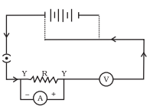 | [2]
21 | - Identify the V - I graphs for ohmic and non - ohmic materials.  - Give one example of each. | [2]
22 | What is the limitation of Ohm’s law? | [2]
23 | Let the resistance of an electrical component remains constant while the potential difference across the two ends of the component decreases to half of its former value. What change will occur in the current through it? | [2]
24 | A current of 30 mA is flowing through a wire of resistance of 50Ω. what is the potential difference between two ends of the wire ? | [2]
25 | State Ohm’s law? How can it be verified experimentally? Does it hold good under all conditions? Comment. | [2]
26 | A V - I graph for a nichrome wire is given below. What do you infer from this graph? Draw a labelled circuit diagram to obtain such a graph. 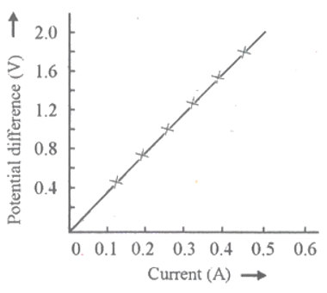 | [2]
27 | The values of the current I flowing in a given resistor for corresponding values of potential difference V across the resistor are given below: 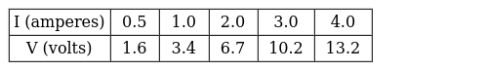  Plot a graph between V and I and calculate the resistance of that resistor. | [2]
28 | The given figure represents V - I graph for a series combination and for a parallel combination of two resistors. Which of the two, A or B, represents the series combination. Give a reason for your answer. 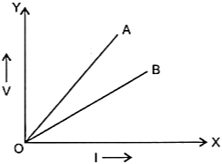 | [2]
29 | What is Ohm’s law? How can it be verified? | [2]
30 | Calculate the resistance of an electric bulb which allows a 10A current when connected to a 220V power source? | [2]
31 | Write three points of difference between an ohmic resistor and non - ohmic resistor. | [2]
32 | How does potential difference (V) across a resistor depend on current passing through it? What is nature of I - V graph obtained? | [2]
33 | While studying the dependence of potential difference (V) across a resistor on the current (I) passing through it, in order to determine the resistance of the resistor, a student took 5 readings for different values of current and plotted a graph between V and I. He got a straight line graph passing through the origin. What does the straight line signify? Write the method of determining resistance of the resistor using this graph. | [2]
34 | The given figure shows the V - I graphs for two resistors. Identify the resistor that obeys ohm’s law. Give a reason for your answer 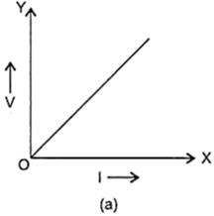  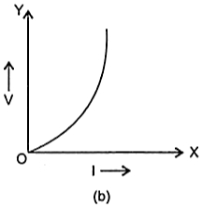 | [2]
35 | The given figures show V - I graphs experimentally obtained for different resistors. Select the graphs for resistors that do not obey Ohm’s law. 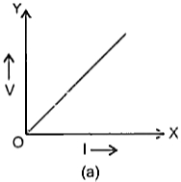  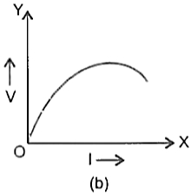  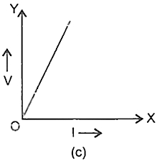  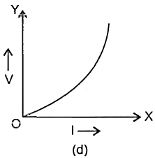 | [2]
36 | Calculate the equivalent resistance of the following electric circuit: 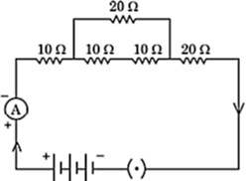 | [2]
37 | - Which is the better way to connect lights and other appliances in domestic circuit, series connection or parallel connection? Justify your answer.  - An electrician has made electric circuit of a house in such a way that, if a lamp gets fused in a room of the house, then all the lamps in other rooms of the house stop working. What is the defect in this type of circuit wiring? Give reason. | [2]
38 | What is the resistance betweenA and B in the network shown in the figure? 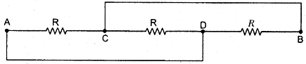 | [2]
39 | Two cells of 3V each are connected in parallel. An external resistance of 0.5$Ω$ is connected in series to the junction of two parallel resistors of 4 $Ω$ and 2 $Ω$ and then to the common terminal of the battery through each resistor. Draw the circuit diagram. What is the current flowing through 4 $Ω$ resistors? | [2]
40 | Three incandescent bulbs of 100 W each are connected in series in an electric circuit. In another circuit another set of three bulbs of the same wattage are connected in parallel to the same source.  - Will the bulb in the two circuits glow with the same brightness? Justify your answer.  - Now let one bulb in both the circuits get fused. Will the rest of the bulbs continue to glow in each circuit? Give reason. | [2]
41 | An electric lamp, whose resistance is 20 Ω, and a conductor of 4 Ω resistance are connected to a 6 V battery. Draw the circuit diagram. Calculate (a) the total resistance of the circuit, and (b) the current through the circuit. | [2]
42 | Draw a schematic diagram of a circuit consisting of a battery of three cells of 2 V each, a 5 Ω resistor, an 8 Ω resistor, and a 12 Ω resistor, and a plug key, all connected in series. | [2]
43 | Why is an ammeter likely to be burnt out if it is connected in parallel in a circuit? | [2]
44 | n resistors each of resistance R is first connected in series and then in parallel. What is the ratio of the total effective resistance of the circuit is series combination and parallel combination? | [2]
45 | A hot plate of an electric oven connected to a 220 V line has two resistance coils A and B,each of 24$Ω$ resistance, which may be used separately, in series, or in parallel. What are the currents in the three cases? | [2]
46 | Why is resistance more in series combination? | [2]
47 | In the circuit given below, calculate the value of x, if the equivalent resistance between the points A and B is 6$Ω$ . 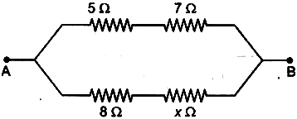 | [2]
48 | How will you conclude that the same potential difference (voltage) exists across three resistors connected in a parallel arrangement to a battery? | [2]
49 | Three 2$Ω$ resistors, A, B and C are connected as shown in figure. Each of them dissipates energy and can withstand a maximum power of 18 W without melting. Find the maximum current that can flow through the three resistors. 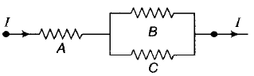 | [2]
50 | Two resistors of resistance R and 2R are connected in parallel in an electric circuit. Calculate the ratio of the electric power consumed by R and 2R? | [2]
51 | Why is resistance less when resistors are joined in parallel? | [2]
52 | Calculate the value of x if the equivalent resistance between the points P and Q as shown in figure is 5$Ω$ . 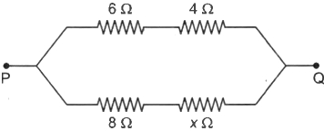 | [2]
53 | Arrange 1$Ω$ , 10 $Ω$ and 100 $Ω$ such that the equivalent resistance is greater than 10 $Ω$ but less than 11 $Ω$ . | [2]
54 | Two resistors of the same material and of equal lengths and equal diameters are first connected in series and then parallel in a circuit across the same potential difference. In which connection (series or parallel) will a stronger current be observed. Explain your answer. | [2]
55 | Write the advantages of connecting electrical appliances in parallel and disadvantages of connecting them in series in a household circuit. | [2]
56 | How will you infer with the help of an experiment that the same current flows through every part of the circuit containing three resistances in series connected to a battery? | [2]
57 | Why is the series arrangement not used for domestic circuits? Explain. | [2]
58 | Consider a network of resistance each of value of R as shown if figure: 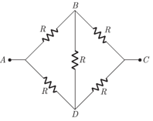  - What is the equivalent of net work between A and C?  - What is the potential of B and D when the voltage source is applied across A and C?  - What is the potential of B and D when the voltage source is applied across A and B? | [2]
59 | Why is parallel arrangement used in domestic wiring? | [2]
60 | - Draw a schematic diagram of a circuit consisting of a cell of 1.5 V, 10 - ohm resistor and 15 - ohm resistor and a plug key all connected in series.  - How would the reading of voltmeter (V) change, if it is connected between B and C as mentioned in the given below circuit diagram? Justify your answer. 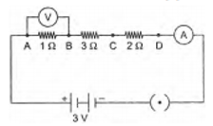 | [2]
61 | What is (a) the highest, (b) the lowest total resistance that can be secured by combinations of four coils of resistance 4$Ω$ , 8 $Ω$ , 12 $Ω$ , 24 $Ω$ ? | [2]
62 | You are given fifty 5$Ω$ resistors. What is  - smallest and  - largest resistance can be obtained by using these? | [2]
63 | Draw a circuit diagram of an electric circuit containing of two resistors ammeter, a resistor of 2$Ω$ in series with a combination of two resistors (4each) in parallel and a voltmeter across the parallel combination. Will the potential difference across the 2 $Ω$ resistors be the same as that across the parallel combination of 4 $Ω$ resistors? Give reason. | [2]
64 | A current of 1 ampere flows in a series circuit containing an electric lamp and a conductor of 5 Ω when connected to a 10 V battery. Calculate the resistance of the electric lamp. Now if a resistance of 10 Ω is connected in parallel with this series combination, what change (if any) in current flowing through 5 Ω conductor and potential difference across the lamp will take place? Give reason. | [2]
65 | An electric lamp of 100$Ω$ , a toaster of resistance 50 $Ω$ , and a water filter of resistance 500 $Ω$ are connected in parallel to a 220 V source. What is the resistance of an electric iron connected to the same source that takes as much current as all three appliances, and what is the current through it? | [2]
66 | How many 10$Ω$ resistors are required to get a 25 $Ω$ resistor? | [2]

